Campaign Form
Create your own online fundraising campaign to support the work of Building Futures. Please fill out as much as you can and email back to us, incomplete information is fine too. development@bfwc.org
- CAMPAIGN TITLE: See example below.
- PERSONAL MESSAGE: This is what your friends, family, and colleagues will see. Share why you are doing this campaign and why you support us, make sure you include your name or your group’s name*
- YOUR NAME AND EMAIL ADDRESS (for internal purposes only):
- AN IMAGE: Please email one image (jpg, gif, png format). We may crop/re-size it.
- START AND END DATE: (ie begin in a month and active for 3 months)
- Optional FUNDRAISING GOAL / DOLLAR AMOUNT (IF ANY): $
- Optional Notification email? Do you want an automatic email notification each time someone makes a donation, and if so, to what email address?
- Optional Progress Bar? Will this form need to have a fundraising progress bar/thermometer?
- Optional keywords? Do you want the URL to be campaigns.givedirect.org/keywords or something different for the keyword? The keyword is the part after campaigns.givedirect.org. Example: campaigns.givedirect.org/BinnsFamily2020
About us: We will add this paragraph on to your personal message. If you prefer to not have it there, please let us know: Building Futures’ mission is to build communities with underserved individuals and families, where they are safely and supportively housed, free from homelessness and domestic violence. Building Futures believes that everyone deserves a safe place to call home. That is why all of Building Futures’ programs and services are aimed at helping their clients overcome their obstacles to permanent housing. Building Futures is proud to provide Alameda County individuals and families in need with Shelter, Domestic Violence Support and Advocacy, and Housing Services. Learn more at http://www.bfwc.org
Background on Starting a Campaign: Online campaigns are a great way for our caring community members, to amplify the impact of their support—introducing their friends, family members, and colleagues to a specific project for Building Futures—or to Building Futures in general. In this way, you serve as a valued ambassador. Creating an online campaign is also a great way to mark a special occasion or milestone, while helping to ensure Building Futures’ tailored programs and services continue to help individuals and families in need. You can honor a special person for a birthday, anniversary, Mother’s Day, or in memoriam. You and your friends, family members, and colleagues participate in helping our community live free from homelessness and family violence by giving to the campaign. Your support makes possible a range of services that help individuals and families build improved lives, free from homelessness and family violence. Amid Alameda County’s housing crisis, Building Futures is needed more than ever. Creating an online campaign is a wonderful way to celebrate a special occasion or milestone, while helping to ensure Building Futures’ programs continue to touch the lives of families and individuals who are working to live free from homelessness and family violence. More: https://bfwc.org/give-support/start-a-campaign/ -- For more information, please contact Ana Maria Mahiri, Director of Development and Communications, 510-357-0205 x204 or development@bfwc.org- See example for Tania here or below:

Nat & Kera’s Emergency COVID-19 Fundraiser for Building Futures
Goal: $4,000
Deadline: April 13, 2020
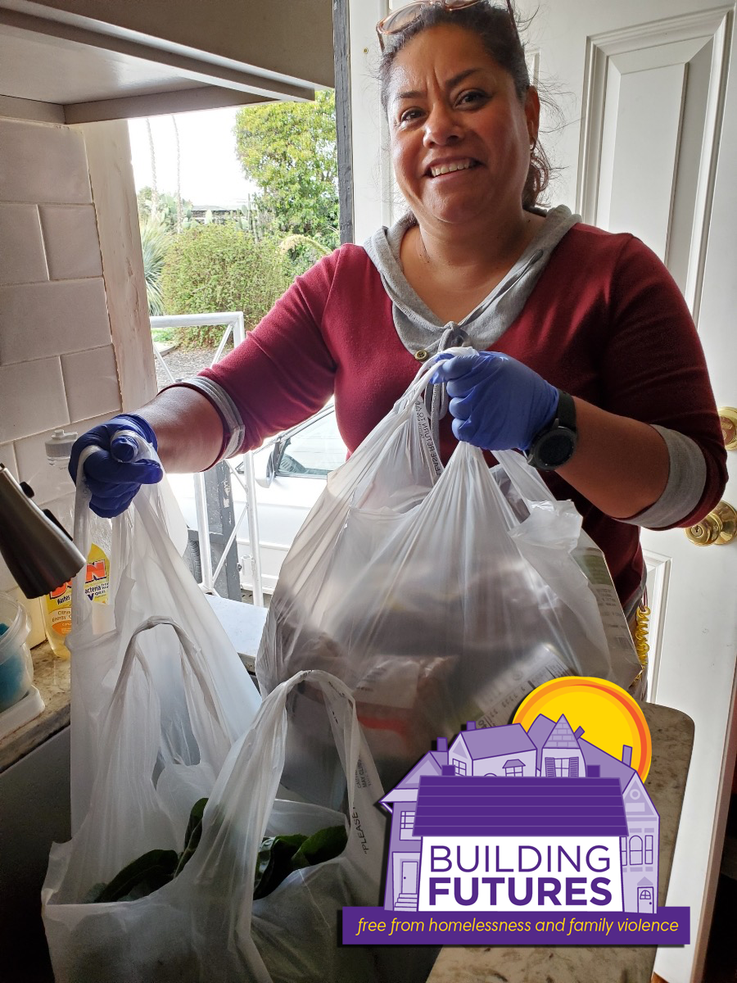
Friends and family -- Kera, Conor and I need your help to support an amazing local organization working on the front line of COVID-19. Building Futures provides essential services to vulnerable families in need of shelter, safety, food and community at five emergency homeless shelters. Their housing programs and domestic violence services are at full capacity -- rather than scale back, they are doing more. Unfortunately, like many other charitable organizations, their fundraising efforts are being hurt by having to cancel events. The folks they serve need our help more than ever, so we set an ambitious goal of raising $5,000. Your donation to this cause would mean so much to our family and do a world of good for people in our community urgently in need of help. Please give whatever you can and thank you all! -- Nat, Kera and Conor Binns

